New Patient Registration
About You
Title: Preferred pronoun:
Forenames:
Middle name(s):
Surname:
Date of Birth: (dd/mm/yy)
Gender: M / F (PLEASE CIRCLE) Gender at birth (if different): M / F
Ethnicity: Country of birth:
First language: Is a translator needed? YES / NO
Landline number: Mobile Number:
Email address:
Religion: First language:
Date entered UK (if not from birth):
Next of Kin name:
Phone number:
Next of kin relationship to you:

We may communicate with you via text or email about various elements of your care...
Do you consent to receiving text messages? YES / NO
Do you consent to receiving emails? YES / NO
Height (cm)
Weight (kg)
Smoking – Do you currently smoke? Y / N
Do you smoke cigarettes, vape, pipe or other? (PLEASE CIRCLE)
If yes, how many a day?
If no, are you an ex-smoker? Y / N
If yes, what year did you quit?
Exercise - Which best describes your exercise routine? (Please circle)
Not able to exercise | Avoid exercise | Light exercise | Moderate exercise | Heavy exercise

Alcohol – Please answer each question below and record your score in the Colum on the right
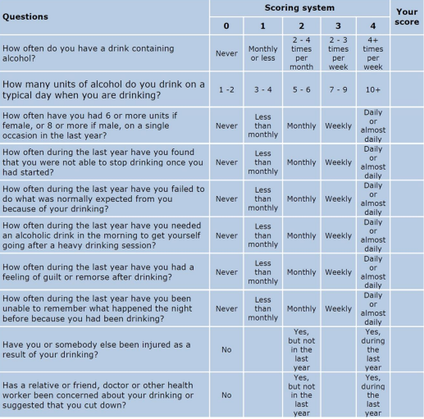
Accessible Information Standards
As a practice we want to make sure that we give you information that is clear to you. For that reason, we would like to know if you have any communication needs.
Do you have any special communication needs? Yes / No
If yes, please state your needs below:
___________________________________________________________________________

Electronic Prescribing Service (EPS)
The EPS allows prescribers – such as GPs and practice nurses to send prescriptions electronically to a dispenser (such as a pharmacy) of the patient’s choice. This makes the prescribing and dispensing process more efficient and convenient for patients and staff. The NHS aim that by 2020 they will hopefully be paper free or a paper-lite service. To help achieve this The As a practice, we would encourage all patients to opt for electronic prescribing.
Do you give consent for my prescriptions to be sent electronically to the pharmacy? Yes / No
Nominated Pharmacy: _______________________________________________________________ ________________________________________________________________

Summary Care Record - Patient Information
If you are registered with a GP practice in England you will already have a Summary Care Record (SCR), unless you have previously chosen not to have one. It will contain key information about the medicines you are taking, allergies you suffer from and any adverse reactions to medicines you have had in the past.
Information about your healthcare may not be routinely shared across different healthcare organisations and systems. You may need to be treated by health and care professionals that do not know your medical history. Essential details about your healthcare can be difficult to remember, particularly when you are unwell or have complex care needs.
Having a Summary Care Record can help by providing healthcare staff treating you with vital information from your health record. This will help the staff involved in your care make better and safer decisions about how best to treat you.
You have the choice of what information you would like to share and with whom. Authorised healthcare staff can only view your SCR with your permission. The information shared will solely be used for the benefit of your care.
Your options are outlined below; please indicate your choice on the consent form on the next page.
a) Express consent for medication, allergies, and adverse reactions only. You wish to share information about medication, allergies, and adverse reactions only.
b) Express consent for medication, allergies, adverse reactions, and additional information. You wish to share information about medication, allergies and adverse reactions and further medical information that includes: Your significant illnesses and health problems, operations, and vaccinations you have had in the past, how you would like to be treated (such as where you would prefer to receive care), what support you might need and who should be contacted for more information about you.
c) Express dissent for Summary Care Record (opt out). Select this option, if you DO NOT want any information shared with other healthcare professionals involved in your care. Please note that it is not compulsory for you to complete this consent form. If you choose not to complete this form, a Summary Care Record containing information about your medication, allergies and adverse reactions and additional further medical information will be created for you as described in point b) above.
The sharing of this additional information during the pandemic period will assist healthcare professionals involved in your direct care and has been directed via the Control of Patient Information (COPI) Covid-19 – Notice under Regulation 3(4) of the Health Service Control of Patient Information Regulations 2002.
You are free to change your decision at any time by informing your GP practice.
Having read the above information regarding your choices, please choose one of the options below and return the completed form to your GP Practice:
Summary Care Record - Consent Form
Yes – I would like a Summary Care Record
□ Express consent for medication, allergies, and adverse reactions only.
OR
□ Express consent for medication, allergies, adverse reactions, and additional information.
No – I would not like a Summary Care Record
□ Express dissent for Summary Care Record (opt out).
If you are filling out this form on behalf of another person, please ensure that you fill out their details above; you sign the form above and provide your details below:
Full Name: ____________________________________________________
Contact Phone Number: ____________________________________
Please circle one: Parent Legal Lasting power of attorney Guardian for health and welfare
If you require any more information, please visit http://digital.nhs.uk/scr/patients or phone NHS Digital on 0300 303 5678 or speak to your GP practice

Online Access to Records
What you need to know about your GP online records
Just like online banking, you can now look at your GP records on a computer, a tablet, or a smartphone, using a website or an App. You can also book and cancel appointments and order repeat prescriptions online.
You can already see some of the information in your GP online records, including your medications and allergies. During the next year, you will be able to see even more. This will include illnesses, immunisations, and test results.
There are several different providers supporting online access; we are working with and recommending myGP. More information on how to get started is available at www.nhs.uk/patientonline
You can look at your records whenever you choose to, without needing to print them. Online records are up to date and more secure than a printed paper record which could get lost or seen by others.

People who have long term conditions, for example diabetes, hypertension, or coronary heart disease, have found that looking at their test results online helps them make positive changes to improve their health. They can see if their condition is improving or getting worse by looking at past test results. Adam, a patient at University Health Centre said, ‘Record access is useful for those, like me, who need to have more regular contact with their GP’.
You can look at your medical records before your appointment to see if there is anything you need to discuss with your doctor or nurse. This could be your test results, illnesses you have had in the past or any new information added to your records. This would help you discuss any concerns you may have and help you benefit more from your appointment.
Sometimes when you see your doctor, you are given a lot of information and might not be able to remember it later. You may also want further information once you have had time to think about what was said. You can look at your online records after your appointment to make sure you understood what your doctor or nurse said.
One of the most useful things patients have found is that you can make sure your medical information is accurate. For example, you will be able to let your doctor know if you have an allergy to a medicine and it is not recorded.
Before you go on holiday, you can check if your vaccinations are up to date without having to go to your surgery

Understanding your records
Your records are written to help medical people look after you and so in some cases, you may not understand everything you see. If you find anything difficult to understand, as well as talking to your doctor or nurse, you can go to the NHS Choices website by using this link www.nhs.uk NHS Choices is the NHS website for patients so you can look for information on illnesses, improving health and to find NHS services in your local area.
There are a few things you need to think about before registering for online records.
- On very rare occasions your GP may not think it in your best interest for you to look at your GP records online. If this happens, your GP will discuss their reasons with you. It is up to your GP to decide if you should be allowed access to your online record.

- You may see your test results before your doctor has spoken to you about them. This may be when you cannot contact your surgery, or when your surgery is closed. This means you will need to wait until an appointment is available to talk to your doctor.
- Information in your medical records might need correcting. If you find something you think is not correct, you should contact your surgery. The staff will be able to answer your questions and set things right when needed. Please bear in mind that you cannot change the record yourself.
- There may be information in your medical records that you did not know was there or that you had forgotten about, such as an illness or an upsetting incident. If you see anything you did not know about that worries you, please speak to your surgery and they will discuss this with you.
- If you see someone else’s information in your record, please log out immediately and let your surgery know as soon as possible.
- If you believe someone had gained access to your records or login details contact the Surgery immediately to block access and reset the login details.
If you have questions about any of the above points, please talk to your surgery and they will be able to advise you further.
If you would like to sign up for access to online records, please complete the following form. Please be advised each person applying requires a different email address.

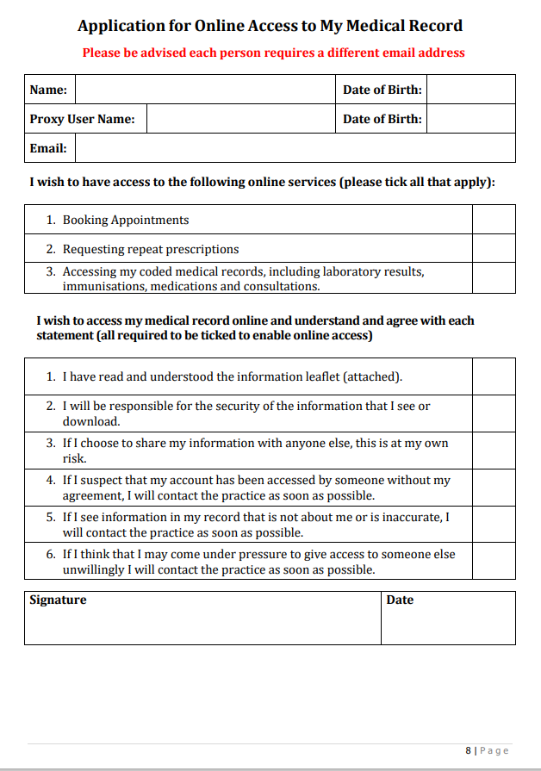
Data Sharing
Data Sharing NHS England aims to link information from all the different places where you receive care, such as hospital, community service and us your GP Surgery. This will allow them to share the care you received in one area with other providers of your medical care.
Information will be held in a secure environment called NHS Digital. The role of NHS Digital is also to ensure that high quality data is used appropriately to improve patient care. NHS Digital has legal powers to collect and analyse data from all providers of NHS care. They are committed, and legally bound, to the very highest standards of privacy and confidentiality to ensure that your confidential information is always protected. This data can also be used, with permission, for research purposes. If you do not wish to share data for research, you can opt out:
- You can object to information containing data that identifies you from leaving the Practice. This will prevent identifiable information held in your record from being sent to the Summary Care Record secure environment. (Further information about the Summary Care Record is below.)
- You can also object to any information containing data that identifies you from leaving NHS Digital. This includes information from all places you receive NHS care, such as hospitals. If you object, confidential information will not leave NHS Digital and will not be used, except in very rare circumstances for example in the event of a public health emergency, for future service planning or for research
For more information visit: www.nhs.uk/your-nhs-data-matters
The law requires Doctors to provide some very limited information about certain things. The law says, for example, that Doctors must provide information to local authorities about some infectious diseases, e.g., if you had food poisoning. Very rarely, Doctors may be required to disclose information to detect a serious crime. Likewise, a court order can require Doctors to disclose certain information during a court case. We will never provide your information to anyone else without your explicit consent. Records which you wish to share with other people such as solicitors will be provided to you so that you can review them before you share them.

FOR GP PRACTICE / OFFICE USE ONLY
Photo ID (for online registration)
Vouched with patient record details
Vouched by member of staff
Staff Name (PRINT): ____________________________________________
Date: ________________

